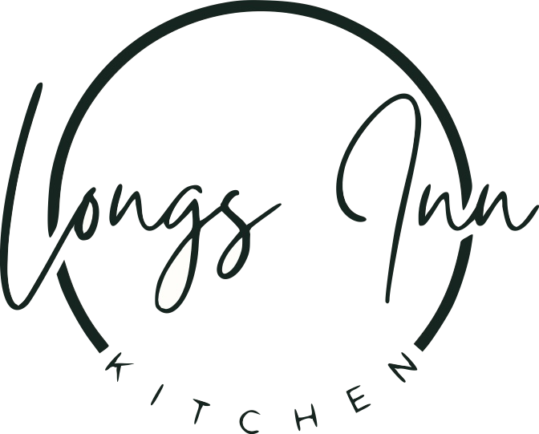

*Welcome to Longs Inn, an idyllic 17th century coaching house with beautiful bar & dining. We hope you enjoy your visit!*

*Please ask your server for todays specials & inform us of any allergens or dietary requirements!*

**SUNDAY ROASTS:**

*Served Sundays Only 12pm-6pm!*

*All Roasts served with homemade Yorkshire pudding, roast potato, cauliflower cheese, seasonal vegetables & bottomless gravy!*

**Roast Beef** £17.50

**Roast Pork** £16.50

**Roast Chicken-** Chicken Breast wrapped in bacon £16.00

**Hungry? Try the Trio-** Slice of Beef, Pork and Chicken! £19.00

**Homemade Vegetarian Mushroom Wellington** £15.50

 **Extra Cauliflower Cheese** £3.00 / **Extra Veggies** £2.00

**Extra Potatoes** £2.50

***Staying in Woburn?*** *Speak to a member of staff about our rooms!*