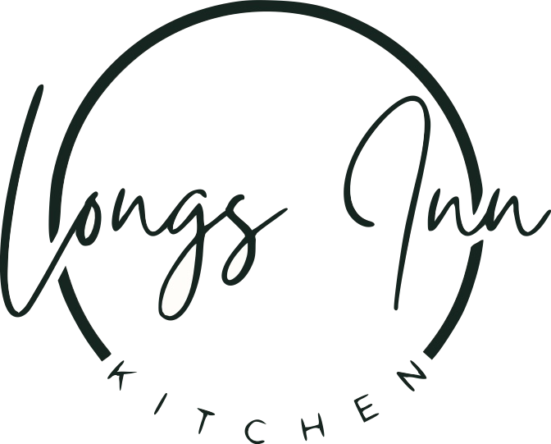

*Welcome to Longs Inn, an idyllic 17th century coaching house with beautiful bar & dining. We hope you enjoy your visit!*

*Please ask your server for todays specials & inform us of any allergens or dietary requirements!*

**VEGETARIAN OPTIONS:**

**SMALL PLATES:**

**Halloumi Bites-** sweet chilli sauce £5.90

**Fries-** Plain £3 Cheese Loaded £4.00

**Bang Bang Cauliflower**- sriracha Mayo £4.25

**Nachos**-ideal to share... jalapenos, cheese and the classic dips £10.25

**MAINS:**

**Sausages & Mash-** two meat free sausages, mashed potato, seasonal vegetables and gravy £13.95 VEGAN

**Beer Battered Halloumi-** with chips, salad and sweet chilli sauce £13.25

**Cheese & Spinach Lattice-** mashed potato, seasonal vegetables and gravy £13.95

**Vegetable Burger-** breaded vegetable burger in a toasted bun with lettuce, tomato & red onion served with fries £13.50 VEGAN

Add Cheese £1.50/ Add fried Egg £1.50

**Home-made Vegetarian Lasagne-** Mixed vegetables with layers of pasta and cheese sauce served with salad & garlic bread £12.95

**Bang Bang Cauliflower Main-** pieces of bang bang cauliflower served with salad, chips and sriracha Mayo £12.95 VEGAN

**SOMETHING SWEET:**

**Apple & Cinnamon Crumble** – custard or ice cream £6.00

**Homemade Chocolate Brownie** – chocolate sauce & vanilla ice cream £6.25

**Vanilla Panna Cotta –** served with red berries & vanilla icecream £5.50



**Sticky Toffee Pudding** – custard or ice cream £5.50

**Cheesecake of the Day** – served with vanilla icecream please ask your server for todays flavour £6.50

**Ice cream selection** – 2 Scoops £3.00 / 3 Scoops £4.00

vanilla / chocolate / strawberry

*Thank you for dining at Longs Inn Kitchen. Please follow us on social media to stay up to date with the latest offers, events & specials!*