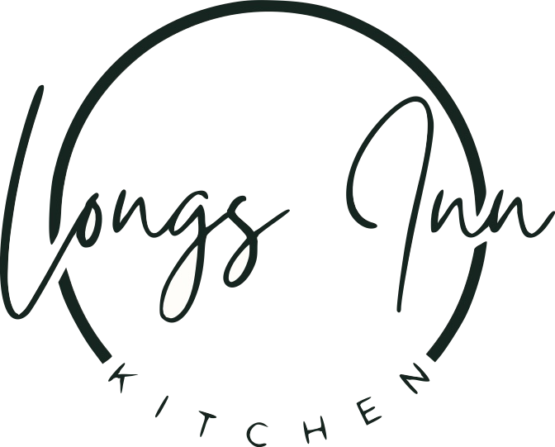

*Welcome to Longs Inn, an idyllic 17th century coaching house with beautiful bar & dining. We hope you enjoy your visit!*

*If you have any dietary requirements or allergies please let us know at time of booking and we will do our best to accommodate you.*

**STARTERS:**

**Breaded Scampi –** tartare sauce £5.95

**Deep Fried Mozzarella Sticks-** sweet chilli dipping sauce £5.95

**Homemade Soup of The Day-** todays flavour served with ciabatta & butter £5.50

**Garlic Bread-** plain £3.00 with cheese £4.00

**MAIN MEALS**

**Pie of The Day**- Todays homemade pie filling topped with puff pastry served with your choice of chips or mash , peas & gravy £15.95

**Sausage & Mash** – 2 Sausages from Hedges Farm, mashed potatoes, peas & onion gravy £14.95 Hungry? Add an additional sausage £2.00

**Ham, Egg & Chips** – Slices of ham, 2 eggs, chips & peas £12.50

Add an additional Egg for £2.00

**Fish & Chips-** Beer battered fish, served with chips, peas & tartare sauce £15.50

**Chicken Curry-** mild homemade chicken curry served with steamed rice £14.00

**Longs Inn Burger-** your choice of deep fried chicken burger or homemade beef burger in a brioche bun with lettuce, tomato, red onion, gherkins & burger sauce £14.95

Make it your own: Add Cheese , Bacon or Fried Egg £2.00

**Ciabattas**- your choice of tuna & sweetcorn , prawn marie rose , ham & cheese or chicken, bacon & mayo served with salad and fries £8.50 (available 12-3 lunchtimes only)



**SWEETS**

**Honeycomb Cheesecake** £6.25

**Homemade Chocolate Brownie** £6.25

**Sticky Toffee Pudding** £6.00

All served with vanilla ice-cream or custard

**2 Scoop Ice-cream Selection**- vanilla , chocolate & strawberry £3.00